

Exploring Acklam
A guided walk with Keith Holtby
July 28th 2011

About 20 people enjoyed the guided walk round Acklam village on a dry evening in July. Keith had prepared a leaflet for everyone which showed the various buildings and places of interest which we visited. As a long-standing resident, he spoke with knowledge and affection for the village.
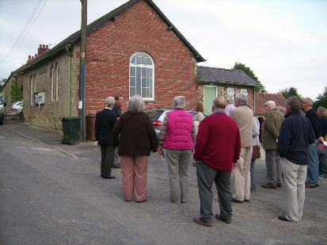
The old school, now the village hall.
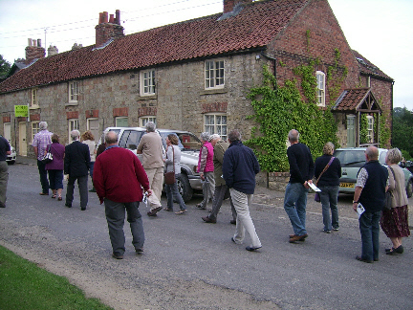
This was the village shop and post office

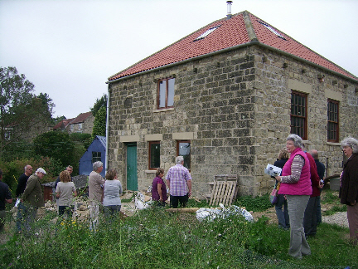
Formerly a chapel – now being converted into a house
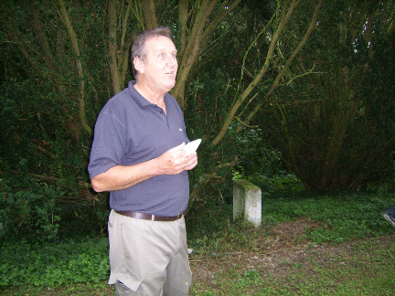Keith spoke about the oldest grave in the churchyard. It was only discovered recently as a result of his work in clearing the overgrown vegetation.

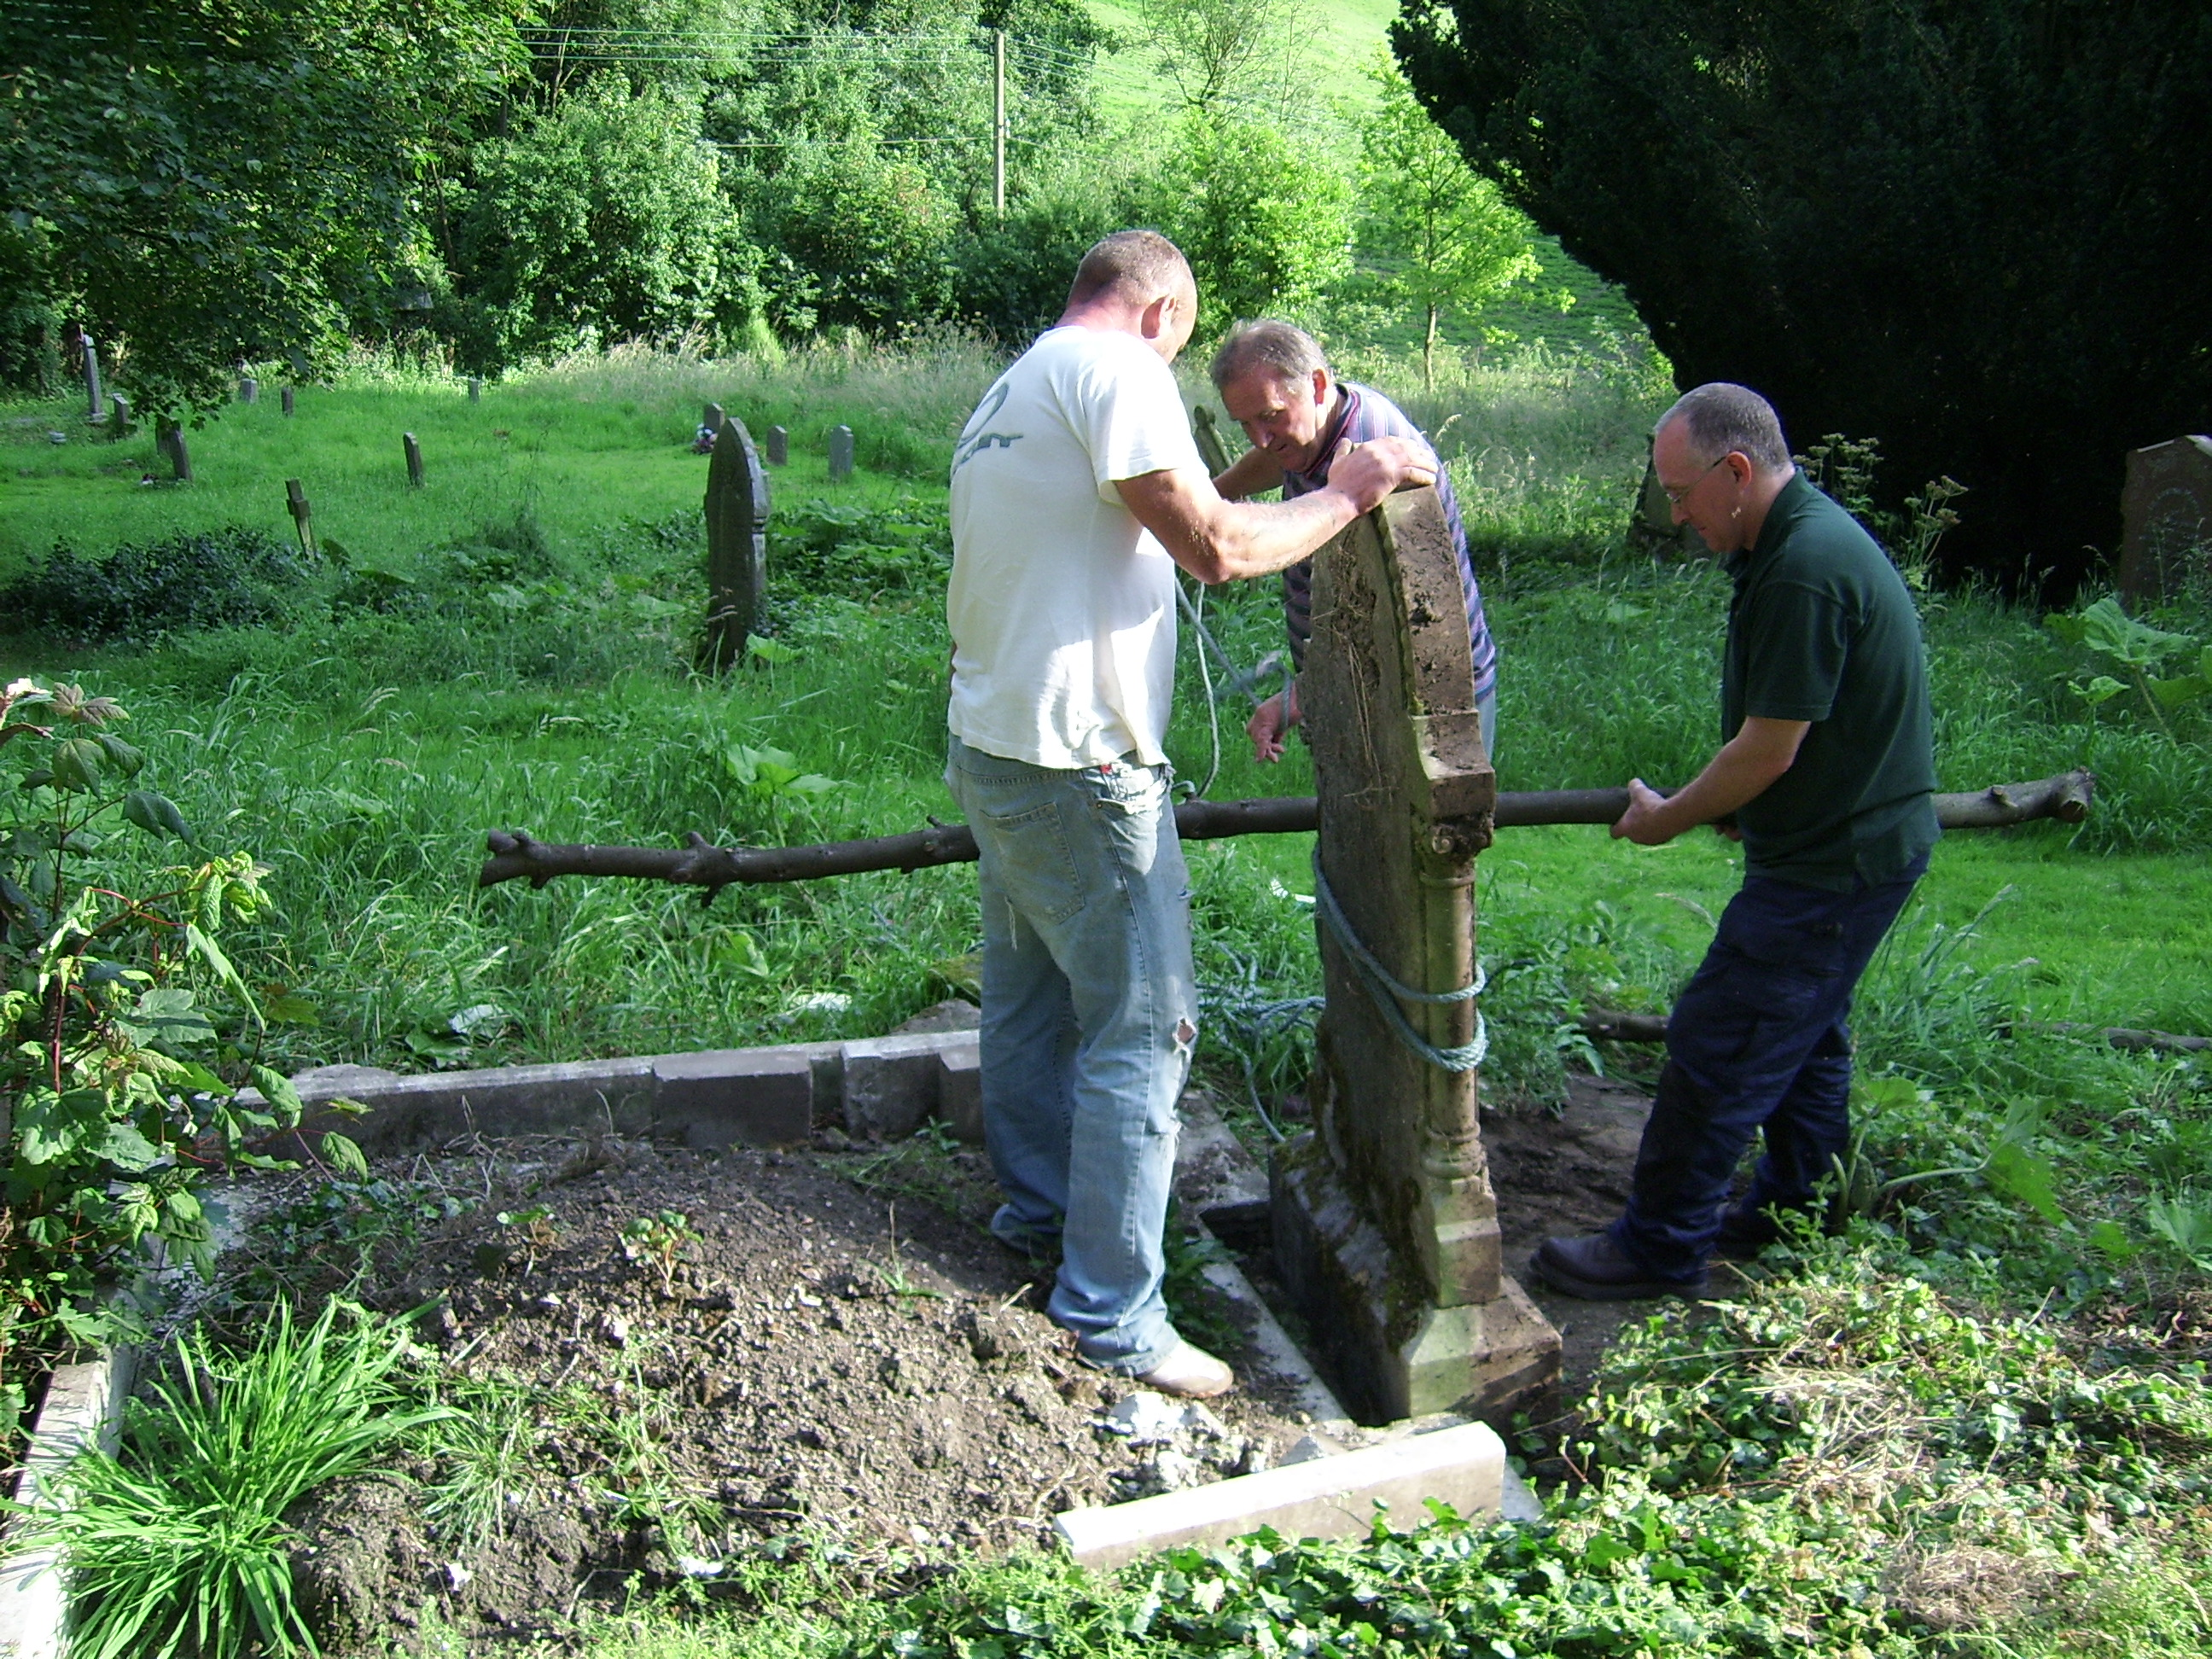
Restoring the grave of John Peterkin, the former shopkeeper in Leavening, and his wife Mary Ann

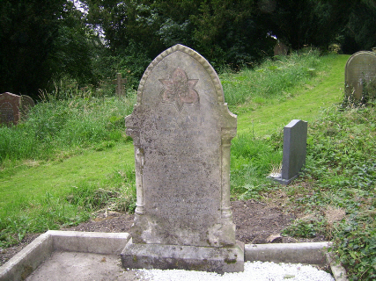 The grave of John Peterkin restored

Keith’s guided walk around the village was followed by a convivial bar meal at the Half Moon Inn, Acklam!

